**Software Development Maintenance Document**

Data Structure

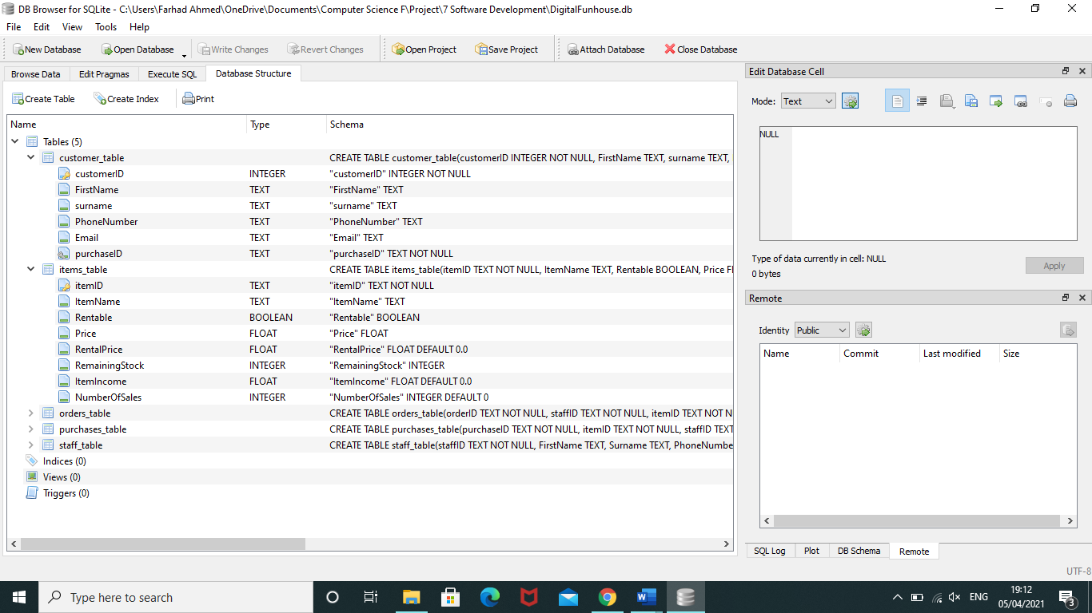

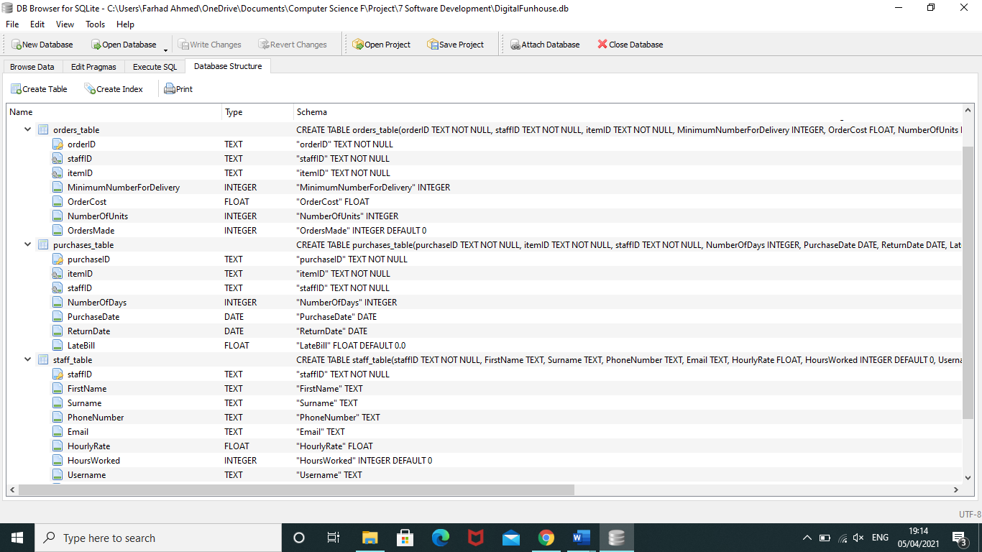

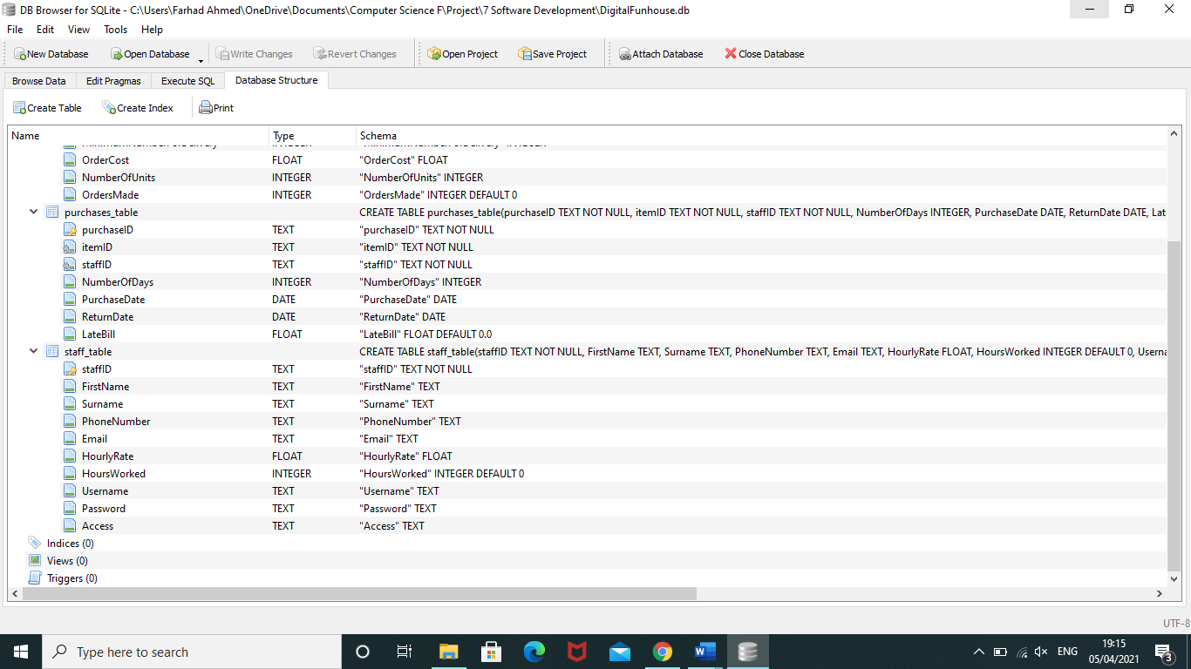

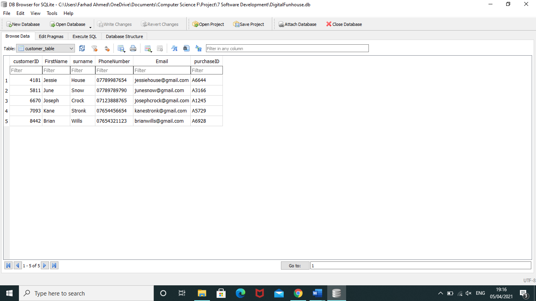

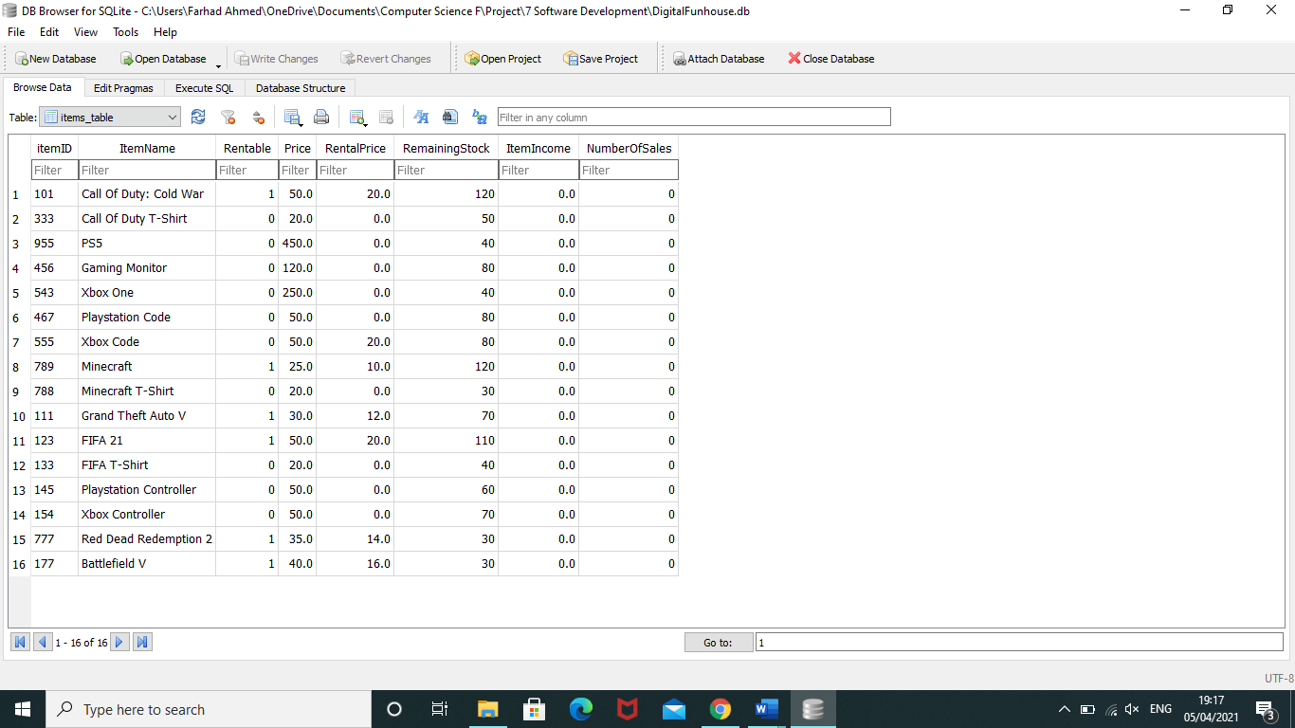

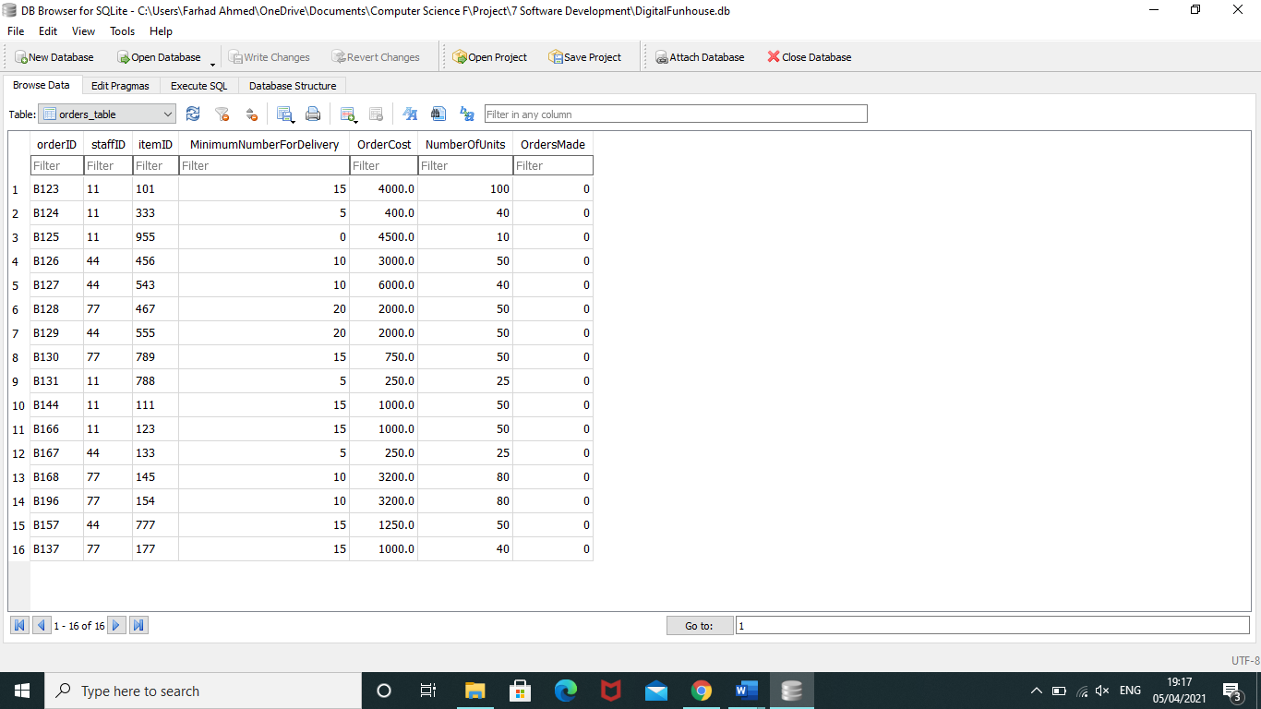

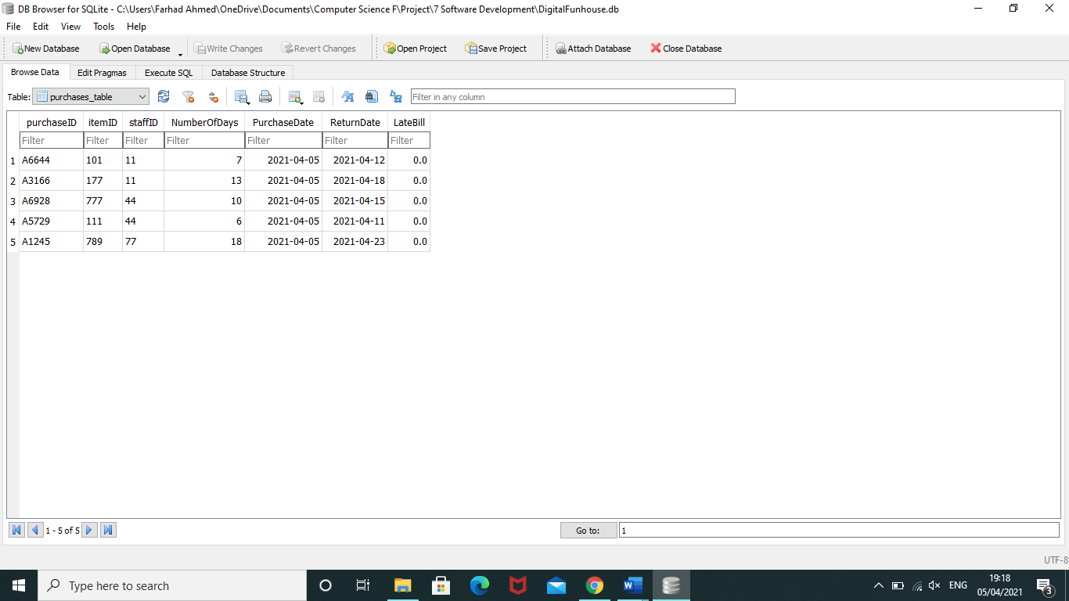

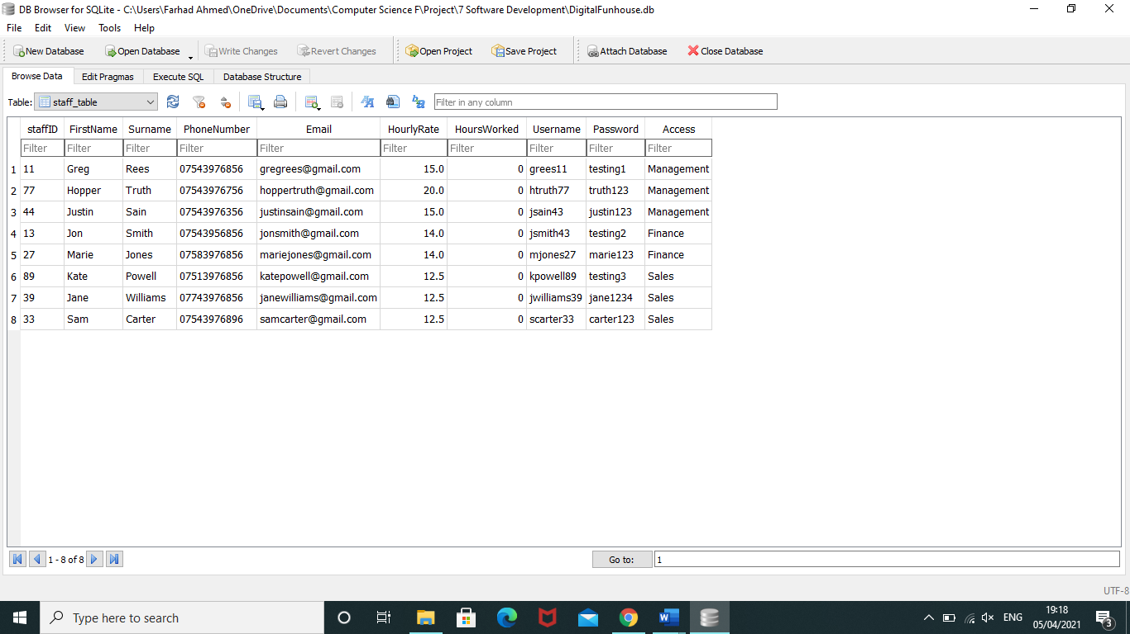

Variables

|  |  |  |  |
| --- | --- | --- | --- |
| **Variable** | | **Function** | **Description** |
| connection | | n/a | Used to connect the system with the databases to be used by the system. |
| c | | n/a | A cursor variable which is used to interact with the databases. |
| customers_checked | | sales_menu | Part of an automatic process which checks whether a customer needs to be reminded about the remaining days left of their rental purchase. |
| option | | sales_menu, finance_menu, management_menu | Used across the whole system. It is used as an indicator that indicates what task the user wants to perform. |
| customerID | | sales_menu, finance_menu, management_menu | Indicates the customer ID wherever it is used in the system. |
| row | | Sales_menu, finance_menu, management_menu | Used across the whole system. It is used whenever data from the database is selected so that the system can use the data. |
| FirstName/firstname | | Sales_menu, management_menu | Used to hold the first name of either a staff or customer. |
| surname | | Sales_menu, management_menu | Holds the surname of a staff or customer. |
| PhoneNumber | | Sales_menu, management_menu | Holds the phone number of a staff or customer. |
| Email/email | | Sales_menu, management_menu | Holds the email of a staff or customer. |
| purchaseID | | Sales_menu | Holds the purchaseID so that databases can be searched using a purchase ID previously retrieved. |
| Record | | Sales_menu, management_menu | Used across the system. Used to hold the record that is selected so that the chosen record can be edited. |
| Edit | | Sales_menu, management_menu | Holds the field that the user wants to edit. |
| update | | Sales_menu, management_menu | Holds the new data that will be inserted into the database. |
| Invoice | | Sales_menu | Holds the text file that will be used to create a customer invoice. |
| Customer | | Sales_menu | Similar to record except this variable holds a customer record which will be used to extract certain data when creating the invoice. |
| Purchase | | Sales_menu | Holds a record from the purchases table so that its data can be used in the invoice. |
| Item | | Sales_menu | Holds a record from the items table so that its data can be used in the invoice. |
| itemID | | Sales_menu, Management_menu | Holds the item ID from the items table to be used in searching the databases. |
| RemainingStock | | Sales_menu | Holds the RemainingStock data from the database which will be used for comparisons against Minimum. |
| Minimum/ MinimumNumberForDelivery | | Sales_menu | Holds the MinimumNumberForDelivery data from its database which will be compared with RemainingStock. |
| Item_name/itemName | | Sales_menu, Management_menu | Holds the itemName data which will be used to search or add a record to the database. |
| Item_reminder | | Sales_menu | Holds the text file that notifies staff members that number of items has went below Minimum. |
| staffID | | Sales_menu, Management_menu | Holds that staff ID data which is used for searching databases. |
| PurchaseDate | | Sales_menu | Holds today’s date which will be the data that an item has been rented. It is also the PurchaseDate from the purchases table. |
| ReturnDate | | Sales_menu | Holds the ReturnDate from the purchases table which will be the date that the item should be returned. |
| NumberOfDays | | Sales_menu | Holds the difference between Return and Purchase date. It is used when the system manages a customer’s rental purchase. |
| Current_hours/HoursWorked | | Sales_menu | Holds the HoursWorked data from the staff table. It will be used when the system is adding the hours the staff has worked. |
| New_hours | | Sales_menu | Holds the number of hours a staff has worked and it will be added onto the HoursWorked. |
| Reminder | | Sales_menu | Holds the text file that will be sent to customers reminding them about their rental purchase. |
| Late_fee | | Sales_menu | Holds the late fee that will be calculated and inserted into the purchases table. |
| payslip | | Finance_menu | Holds that text file that will be sent to all employees when they get paid. |
| Order_costs | | Finance_menu | Holds the costs of all orders made by multiplying OrderCost and OrdersMade. |
| Staff_costs | | Finance_menu | Holds the staff costs by multiplying HourlyRate and HoursWorked. |
| Item_income/ItemIncome | | Finance_menu, Management_menu | Holds the income generated from the selling of items. It will be used when generating reports. |
| Report | | Finance_menu | Holds the text file of the report that will be created. |
| Max_sales | | Finance_menu | Holds the income generated by the most sold item. |
| Max_item | | Finance_menu | Holds the highest selling item. |
| Max_report | | Finance_menu | Holds a sentence describing the highest selling item. |
| Min_sales | | Finance_menu | Holds the income generated by the least sold item. |
| Min_item | | Finance_menu | Holds the income generated by the least sold item. |
| Min_report | | Finance_menu | Holds a sentence describing the lowest selling item. |
| HourlyRate | | Finance_menu, Management_menu | Holds the HourlyRate data from the staff table. Used in calculating a staff’s pay. |
| Username | | Management_menu | Holds the Username data from the staff table. It will allows a staff member to access the system. |
| Password | | Management_menu | Holds the password data from the staff table. It will be used to access the system. |
| Access | | Management_menu | Holds the Access data from the staff table. Will be used to determine which menu a staff member will get access to. |
| Rentable | | Management_menu | Holds the Rentable data from the items table. Used when inserting data into the items table. |
| Price | | Management_menu | Holds the Price data from the items table. Used when inserting data into the items table as well as calculating income. |
| RentalPrice | | Management_menu | Holds the RentalPrice data from the items table. Used when inserting data into the items table. |
| NumberOfSales | | Management_menu | Holds the NumberOfSales data from the items table. Used when calculating income. |
| orderID | | Management_menu | Holds the order ID data from the orders table. Used when searching data from databases. |
| Added_stock/NumberOfUnits | | Management_menu | Holds the NumberOfUnits data from the orders table. Will be used when making an order by adding this variable with the RemainingStock variable. |
| OrdersMade | | Management_menu | Holds the OrdersMade data from the orders table. Used when calculating business costs due to orders. |
| Cost/OrderCost | | Management_menu | Holds the OrderCost data from the orders table. Used when calculating business costs due to orders and when creating a business invoice. |
| Business_invoice | | Management_menu | Holds the text file that contains the details from a delivery. |
| Login | n/a | | Used to determine whether the Username and Password entered into the system matches the data from the databases. |

User Interface

**Login Menu**

This user interface is being used for when the system is booted up. The user is greeted with text that tells them to enter their username and password so that they can login and start using the system. I have designed the user interface like this as it is clear what the user needs to do when they see the interface.

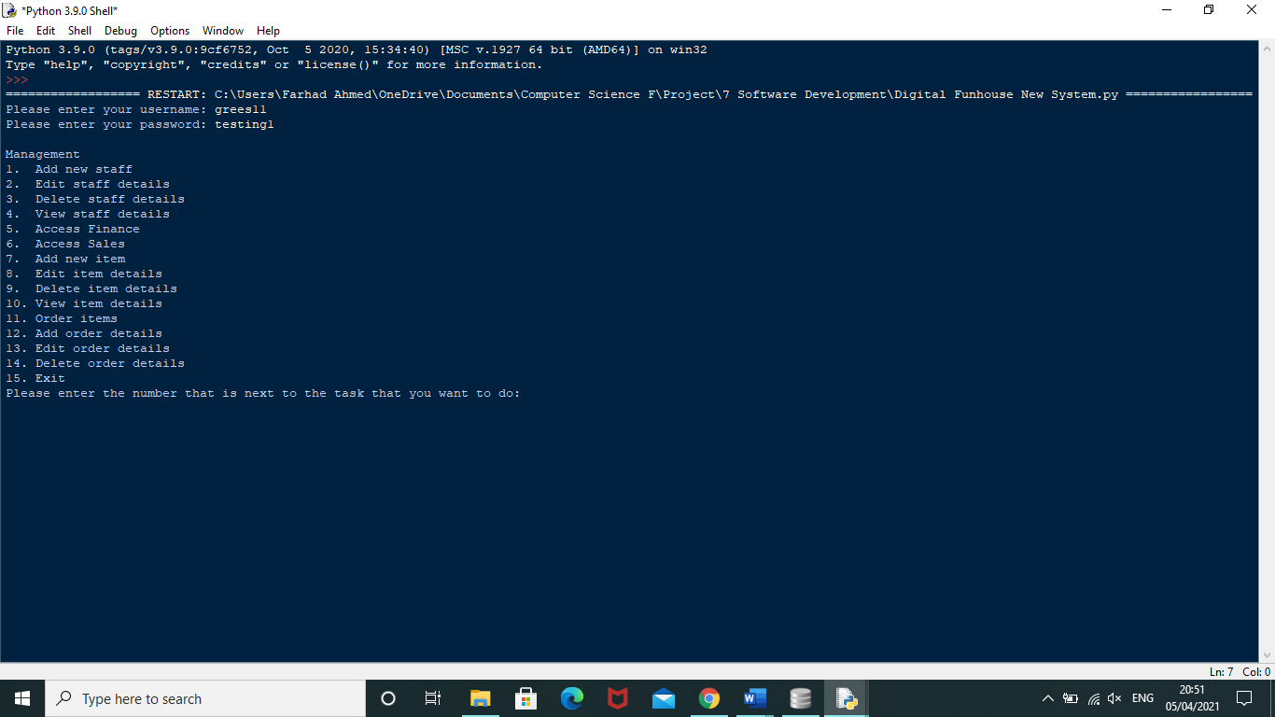

**Management Menu**

This user interface is being used for the management menu. The management user is given a bunch of tasks that they are able to do by entering the number that is next to the name of the task. I have designed the user interface like this as the name of the menu is easily visible at the top of the menu. The tasks are listed by number making it clear that you need to enter that number.



**Finance Menu**

This user interface is being used for the finance menu. The finance user is given a bunch of tasks that they are able to do by entering the number that is next to the name of the task. I have designed the user interface like this as the name of the menu is easily visible at the top of the menu. The tasks are listed by number making it clear that you need to enter that number.

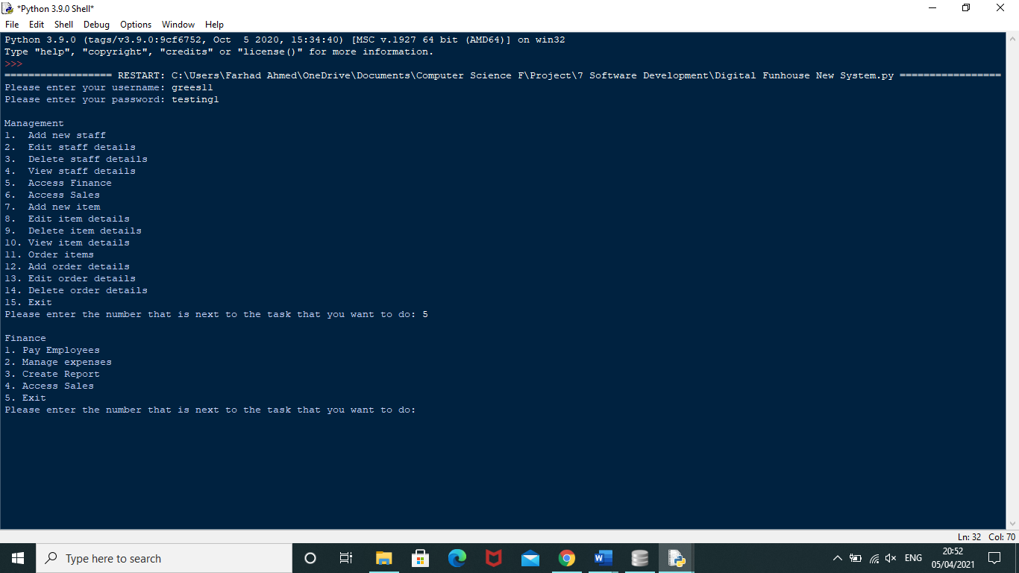

**Sales Menu**

This user interface is being used for the sales menu. The sales user is given a bunch of tasks that they are able to do by entering the number that is next to the name of the task. I have designed the user interface like this as the name of the menu is easily visible at the top of the menu. The tasks are listed by number making it clear that you need to enter that number.

